lab 07 11th July 2023

# 1.

student

|  |  |  |  |  |
| --- | --- | --- | --- | --- |
| **studentID** | yearEnroll | surname | Date_Of_Birth | programID |

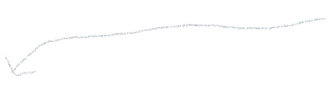Program

|  |  |  |  |
| --- | --- | --- | --- |
| **programID** | Name | creditPoints | yearCommenced |

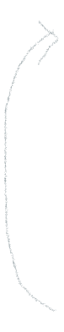

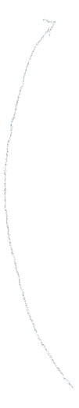Course

|  |  |  |  |  |
| --- | --- | --- | --- | --- |
| **programID** | **courseID** | name | creditPoints | yearCommenced |



Student_course

|  |  |  |  |  |  |
| --- | --- | --- | --- | --- | --- |
| **studentID** | **courseID** | year | semester | marks | grade |

Student_given

|  |  |
| --- | --- |
| **studentID** | **givenNames** |

Assumptions